Project 2

Title:

Text Hold’em V15

Course:

csc-5

Due:

02/14/2020

Author:

Kristopher Ottinger

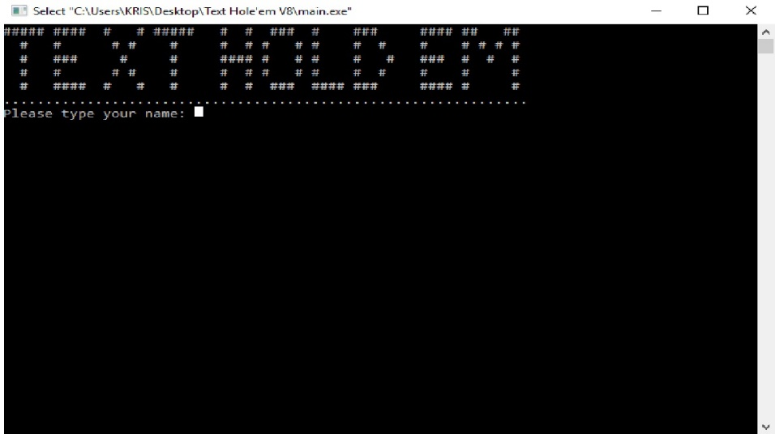1.1 Introduction: This game is based around texas hold’em, were you play against 4 other bot players. You are given 3 options per round and there is 3 rounds per match. Each round there is a small blind and a big blind that start the pot and both rotate per round. After the 3 round your cards are compared against house cards and so are the three bot’s cards, and whoever has the higher pair will win the round and pot. Win all the money and win or lose your money and you lose.

1.2 Game options: After you are given your random cards the house will flop three cards onto the table, you then can compare your cards against the house’s cards and choose an option.

Option one is you can Call/Bet, calling will match the Big Blind or Small blind difference on the first round and then allows you to simply wait till the next house card is flopped then your option are given again. After the first round you then can simply check, which allow you to wait out the turn without matching the Small Blind or Big Blind.

Option two is to bet, on the first round you must bet higher that the Big Blind in order to progress, after which you may bet any amount as long as you have the money to bet.

Option three is to fold, folding will end the round and the bot with the best hand will win the pot.

1.3 Money: Money is the target of the game, hold onto your money by besting the other bots and you can slowly drain their wallets, but if you have a bad hand and lose then your money is lost forever. Each player is given a starting amount of $500 to play with, the bots will only match the Big Blind and Small Blind therefore they will hold onto their money for a while. You must know when to bet and when to call/check or fold to slowly drain their money. If successful then you can win the game!

1.4 Winning: To win each round you must have a better hand than you opponents, in this version of the game you are limited to single pairs, double pairs, three of a kind, flush , full house or four of a kind. You cannot win with a strait, strait flush or royal flush at this time. The order of winning hands is as follows from least to greatest:

* one pair - least
* two pair
* Three of a kind
* Flush
* Full house
* 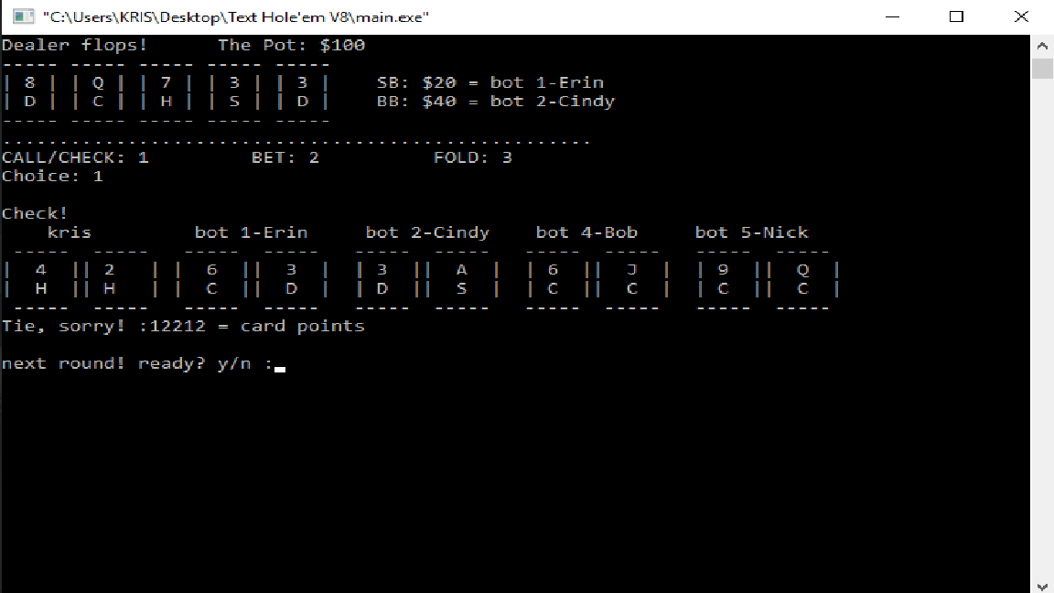Four of a kind - greatest

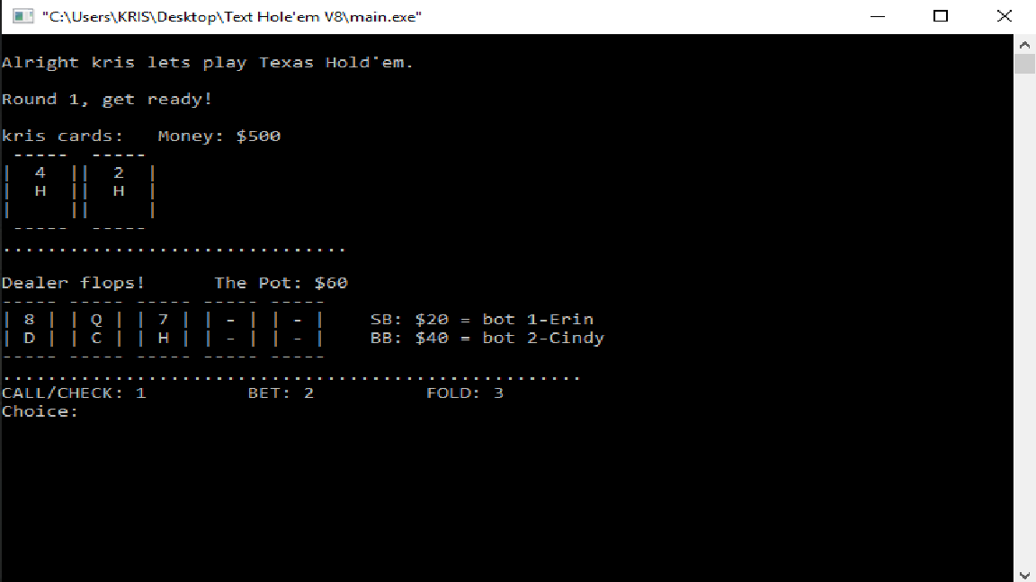User Inputs: The user aka (Player) will be asked to first input his/her name. Then after each flop of the house cards the user will be asked to choose from three options (1-3), if the user chooses an option outside the range you will then have to input the correct choice again, This might take up to five attempts to get the game going again, and after each round is over you can choose to quit the game or continue by entering either y/n.

Bug/Issues: Part of this games challenge is its bugs! This game has some know issues with the scoring mechanism, while it will correctly score a majority of the time sometimes the scoring mechanics will give point to cards that don’t match. There will be updates to this version to patch a majority of these issues and to add a faster way to drain the bots money so you can win faster. But for now this version has some quarks about it.

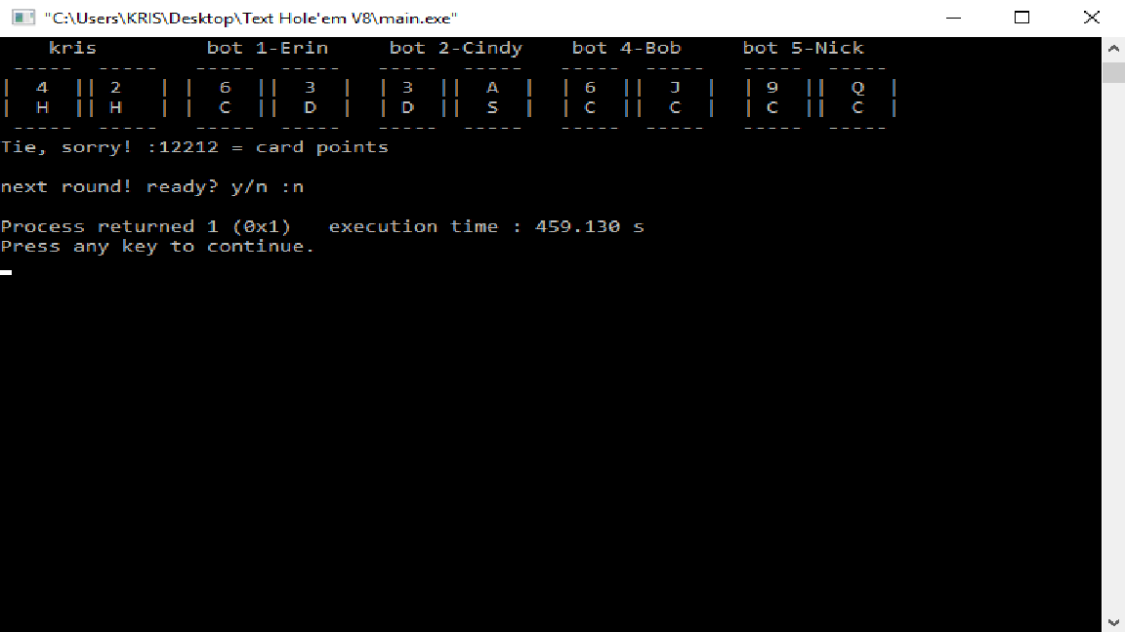

Flowchart: A saved Draw.io version is in the file so you don’t have to hurt your eyes.

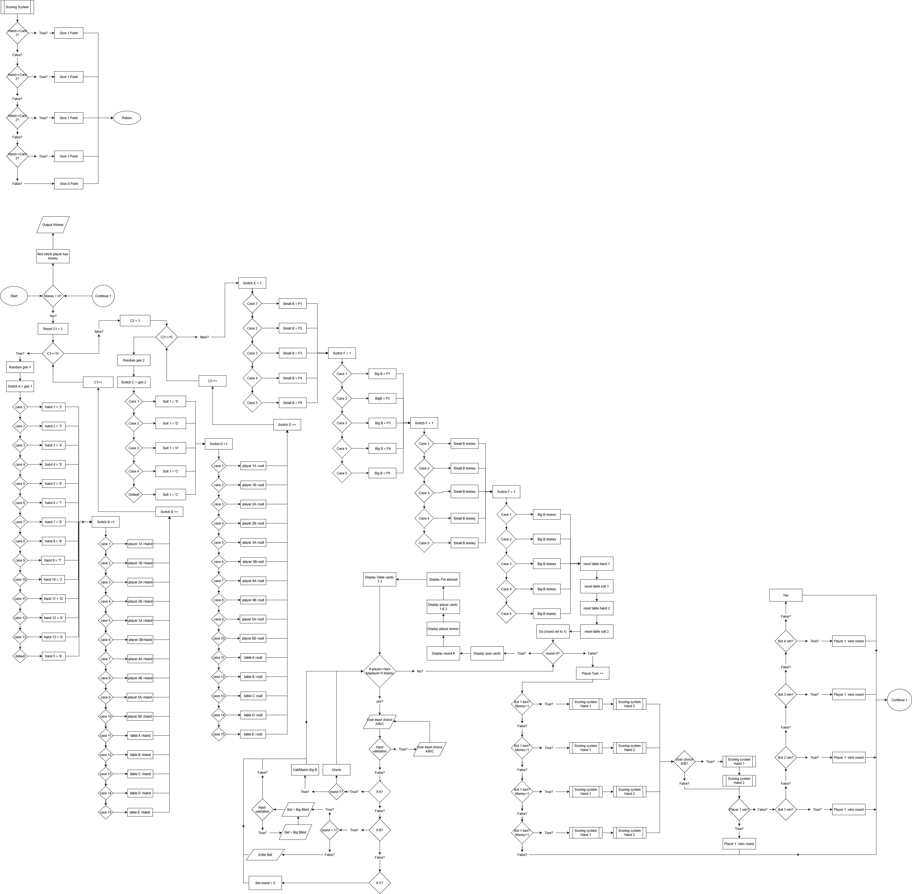

Sample pseudocode:

//\*\*\*\*\*\*\*\*\*\*\*\*\*\*\*\*\*\*\*\*\*\*\*\*\*\*\*\*\*\*\*\*\*\*\*\*\*\*Card Selection Start\*\*\*\*\*\*\*\*\*\*\*\*\*\*\*\*\*\*\*\*\*\*\*\*\*\*\*\*\*\*\*\*\*\*\*\*\*\*\*\*\*\*\*\*\*\*\*

//Reset player card gen loop

//Reset player suit gen loop

//Reset Pot back to 0 for new game

//Player card generator section.

//Random number-gen to select a card face value.

//Hand case values 1-13 = card face value

//Card to player hand assignment.

//Incrementing variable to select next players hand to deposit random hand value in.

//Player suite generator.

//Random number-gen for selection of card suite value.

//Suite case values 1-4 = card suite values.

//suite to card assignments.

//Incrementing value to select next players hand to deposit random suite value in.

//\*\*\*\*\*\*\*\*\*\*\*\*\*\*\*\*\*\*\*\*\*\*\*\*\*\*\*\*\*\*\*\*\*\*\*\*\*\*\*\*Card Selection END\*\*\*\*\*\*\*\*\*\*\*\*\*\*\*\*\*\*\*\*\*\*\*\*\*\*\*\*\*\*\*\*\*\*\*\*\*\*\*\*\*\*\*\*\*\*\*

//\*\*\*\*\*\*\*\*\*\*\*\*\*\*\*\*\*\*\*\*\*\*\*\*\*\*\*\*\*\*\*\*\*\*\*\*\*\*\*\*Small/Big Blind Selection Start\*\*\*\*\*\*\*\*\*\*\*\*\*\*\*\*\*\*\*\*\*\*\*\*\*\*\*\*\*\*\*\*\*\*\*\*\*\*

//Incrementing values to assign the Small Blind to a player.

//Incrementing values to assign the Big Blind to the player after Small Blind.

//Incrementing values to have Small Blind place $20 dollars

//Incrementing values to have Big Blind place $40 dollar

//\*\*\*\*\*\*\*\*\*\*\*\*\*\*\*\*\*\*\*\*\*\*\*\*\*\*\*\*\*\*\*\*\*\*\*\*\*\*\*\*\*\*\*\*Small/Blind Selection END\*\*\*\*\*\*\*\*\*\*\*\*\*\*\*\*\*\*\*\*\*\*\*\*\*\*\*\*\*\*\*\*\*\*\*\*

Check Of Sheet: A version will be located in the file.



